**THE PEARL EXAMINATIONS 2024**

**TERM II QUALITY ASSURANCE**

**BABY CLASS: (3 – 4 YEARS)**

**LEARNING AREA 5: LANGUAGE DEVELOPMENT II**

**My name is: ………………………………..………………………….**

**My School is: ……………………………..……….…………………..**

**I am in: ………………………………..…………………………………………..**

1. **Say the sounds**

**p**

**s**

**t**

**i**

**aa**

**n**

1. **touch on sound a**
2. **touch on sound s**
3. **Colour sound (a)**

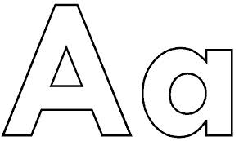

1. **Trace sound (s)**



1. **Circle the same sounds.**

s e s

a k a

i i g

l p p

n h n

1. **Match a sound to a friend.**

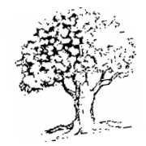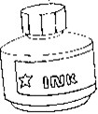

s

a

t

i

**END**